The School District Organizational Assessment Questionnaire (OAQ) Protocol

For School Districts

**Purpose:** The Organizational Assessment Questionnaire (OAQ) provides comprehensive information for planning CalFresh Healthy Living (CFHL) work in school districts. When completed regularly, the OAQs also help to track any changes happening related to nutrition and physical activity at school districts. The OAQ is required for all school districts partnering with local health departments (LHDs) to implement CFHL policy, systems, and environmental change (PSE) interventions *districtwide*.

The questionnaire assesses what nutrition and physical activity related policies, practices, programs, and environments are in place districtwide and helps to identify opportunities that can help make the healthy choice the easy choice for the children and families your schools serve. Responses should reflect the ***current status***, even if the situation temporarily differs from “usual practice” due to a health and/or safety emergency such as the COVID-19 pandemic, wildfires, or another situation. Your responses should not include planned or anticipated changes. This helps establish a clear picture of the current situation and gives you and your CFHL program partners greater insight on what actions to prioritize.

If you’d like additional information on how the OAQ was developed and how it can be used, take a look at the [OAQ one-pager](https://ucanr.edu/site/npi-assessment-questionnaires/resources).

# **Checklist for Completing an OAQ**

*Use this checklist to track your progress towards OAQ completion*.

* Meet with your CFHL LHD partner to discuss why, how, and when to complete the OAQ.
  1. Identify a District Lead (may be yourself) to coordinate OAQ completion.
  2. Identify additional district staff that may need to assist in OAQ completion.
     + Consider whether the District Wellness Committee can support OAQ completion, possibly as an agenda item at a standing or special meeting.
     + For some questions, you may need to reach out other district staff such as: District Superintendent, Nutrition or Food Service Director or Assistant Director, Physical Education Department, Health Education Department, Early Education Department, School Nurse or Health Coordinator, Wellness Champion, or Wellness Policy Committee Lead.
  3. Discuss and record a deadline for completing the OAQ
     + Completion date: ___________________
* Determine who on your team should receive a copy of OAQ responses and score summary, once completed and submitted online. You may include up to two email addresses.
  + - **Important note!** Only enter ONE email address into each field. If multiple addresses are entered into one field, the email summary will not be sent.
* Decide which method you will use to complete and submit the OAQ: Method 1 (paper/electronic document) or Method 2 (online). Detailed steps for each method are on the next page.
  1. Inform your CFHL partner of your chosen method.
  2. Together with other staff, collect all information requested.
* Obtain your most recent [Wellness School Assessment Tool (WellSAT) Policy](https://www.wellsat.org/) Scores.
  1. The WellSAT Policy administration needs to have occurred in the ***last 3 years***.
  2. If your district does not have a recently completed WellSAT Policy, complete the assessment on the [WellSAT](https://www.wellsat.org/) website before beginning the OAQ.
  3. We also strongly encourage you to redo the WellSAT Policy whenever significant changes are made to district wellness policy.

*Note: You do not need to complete the WellSAT Practice.*

* Complete the OAQ
* The LHD will follow up with you to discuss:
  1. Final responses and scores.
  2. **Action planning.** What items have room for improvement and what areas your district may want to focus on as part of CFHL efforts? The LHD may want to use the [School Wellness Policy Action Plan Template](https://ucanr.edu/sites/SLAQ/Resources/#Planning) with you to help guide discussions.

*Congratulations! You have completed the OAQ! Thank you for participating.*

## **A step-by-step overview of the two methods you can use to complete an OAQ**

*Review each option and decide which method to use. Inform your CFHL Partner of your choice*.

### **Method 1: Using a paper or electronic document**

1. Download a MS Word or PDF version of the [OAQ](https://ucanr.edu/sites/SLAQ/SLAQ_Questionnaires/School_District_OAQ/).
2. Print and complete on paper or fill out the MS Word version on your computer.
3. When the OAQ is complete, decide with your CFHL partner who will enter the questionnaire into [Survey 123](https://ucanr.edu/sites/SLAQ/SLAQ_Questionnaires/School_District_OAQ/).
   * 1. **District Lead enters into Survey123:** If your District Lead will enter the OAQ responses into Survey123, see instructions for Method 2 (online completion).
     2. **CFHL partner enters into Survey123:** If the CFHL partner will enter the OAQ responses into Survey123, double check your OAQ for completeness and send back to your CFHL contact. If any questions are left blank, they will follow up with you.

#### **Method 2: Online**

1. Your CFHL contact will send you the Survey 123 link or you can find it [here](https://ucanr.edu/sites/SLAQ/SLAQ_Questionnaires/School_District_OAQ/).
2. Click on the Survey123 link for the School District OAQ.
3. Complete the online survey (see notes below).
4. Let your CFHL contact know the OAQ was submitted.

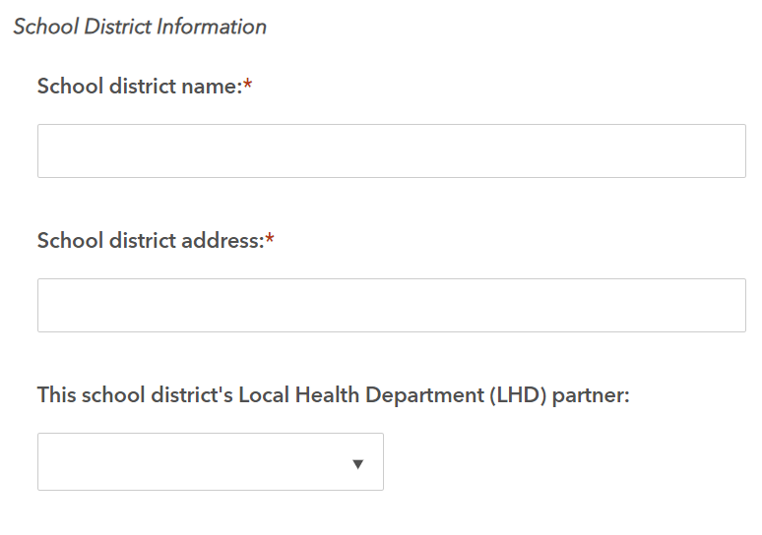

Notes about the school district information section: If you do not find your school district’s name in the drop-down list, you can manually enter the district name, address, and Local Health Department partner name (pictured here).